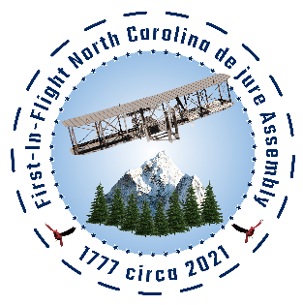
Date Received by FNCA

First-In-Flight North Carolina de jure Assembly (“FNCA”)
Member Form
(This application can be filled out by teleconference.)
Applicant Information

Legal
Name:
First Name Middle Last
(Name on social security card)

Physical
Address Street Apt #

City State County ZIP Code

Other
Address P. O. Box

City State County ZIP Code

Cell Phone: Land Line:

Email:

Are you willing to sign up at Telegram.org?: Yes No
Are you a resident of North Carolina? Yes No
Are you a citizen of the United States? Yes No
Are you over 16 years old? Yes No
Have you been convicted of a felony: Yes No
Are you willing to contribute financially? Yes No
Are you willing to agree to a criminal background check? Yes No
Are you currently a member or agent of the military or any law enforcement agency or of the state or local government?
Yes No
Education
High School: City, State:
From: To: Did you graduate? Yes No

College: City, State:

From: To: Did you graduate? Yes No Degree:
Other studies:
Please State Your Reason for Joining Please include your areas of passion and approximately how many hours you can contribute per week. On a scale of
1 – 10 please indicate how passionate you are about the FNCA and your part in it.
Areas of passion & approximate hours:
Skills and Experience Please list any particular skills or experiences that you wish to bring to the FNCA. A curriculum vitae and/or resume
may be included (in a separate document.) Additionally, a copy of your Driver’s License is required.

Are you willing to hold a FNCA office? Yes No

Which office are you willing to hold?

Related leadership experience:

Are you or have you been a member of a state or local assembly?
Yes No
If so, which one?

Interview Are you willing to have a telephone or Zoom interview? Yes No
If yes, please list best days/times to reach you including time zone:

Please provide a personal reference and their phone number:

Military Service

Are you a military veteran? Yes No Branch:

From: To: Rank at Discharge: Type of Discharge:

If other than honorable, explain:

Disclaimer
I certify that my answers are true and complete to the best of my knowledge. I certify that I have read and am willing to abide by the “Resolution of One Accord” and I have read and am willing to abide by the “Bylaws, Policies and Procedures for the
First-In-Flight North Carolina de jure Assembly.”
If this application leads to acceptance into the First-In-Flight North Carolina de jure Assembly, I understand that false or misleading information in my application or interview may result in my release.

Name: Date:

We will follow up with you. Thank you for your interest in helping to restore North Carolina!

Officer Comments:

Signed Resolution of One Accord Received? Yes No

Signed Bylaws Received? Yes No

Photo Received? Yes No

Resume Received? Yes No

Attended 6 meetings? Yes No N/A

Signed NOA? Yes No

Name of sponsoring member/mentor

Membership Approved? Yes No

FNCA Officer Name: Completion Date:

